

Project Title: FarmConnect Kenya | FarmConnect Kenya
Student Name | Gideon Kibet Rono
Admission Number | BSCCS/2024/60885
Course
Unit Code | BIT3208
Lecturer Name | Mr nyoro
Semester | Year 3 semester 2
Technologies Used | PHP, MySQL, Bootstrap, JavaScript, Laragon
Githhub link | https://github.com/account/fabian-nexus

Contents
Week 1. Local environment 4
Figure1. Installation 4
Fig 2: Apache and MySQL Running 5
5
Fig 3 Local host test page 6
6
Week 2. Wireframes and GUI design 7
Figure 2.0 system/ architectural design 7
Fig 2.1 Designed homepage 8
Fig 2.2 Designed login page 9
Fig.2.3 Designed registration page 9
Fig 2.4 farmer dashboard 10
Fig2.5 Planned customer dashboard 10
Fig 2.6 admin dashboard 11
Fig 2.7 Navigation structure 12
FIG 5. GUI Prototype in Figma 13
Fig 5.1 System architecture 13
Fig 5.2 System workflow 13
Reflection 13
Week 3.Frontend Interaction and Backend Foundations 14
Fig 1: Registration Form Validation 14
Fig 2: Login Authentication System 16
Fig 3: Farmer Product Management Module 17
Fig 4: Customer Marketplace Module 18
Reflection 19
Week 4.Farmer Module development 20
Fig 4.1: Farmer Registration Module 20
Fig 4.2: Farmer Dashboard Interface 21
Fig 4.3: Add Product Form 22
Fig 4.4: Product Management Interface 22
Fig 4.6: Farmer Orders Module 23
Fig 4.7: Customer Inquiries Module 23
Week 5. Database components and crude operation 24
Customer module development 24
Fig 5.1: Customer Registration Module 24
Fig 5.2: Customer Dashboard 25
Fig 5.3: Product Marketplace 26
Fig 5.4: Product Details Page 26
Fig 5.5: Customer Order Management 27
Reflection 27
Week 6. Database components and crude operation 28
6.1 Customer Order Placement System 28
Fig 6.1: Product Selection for Ordering 28
Fig 6.2: Order Placement Module 28
Fig 6.3: Order Processing Logic 28
Fig 6.4: Successful Order Submission 28
Fig 6.5: Order Record Verification 28
Reflection 28

Week 1. Local environment
Title
Installation and Testing of Local Development Environment
Evidence

Figure1. Installation
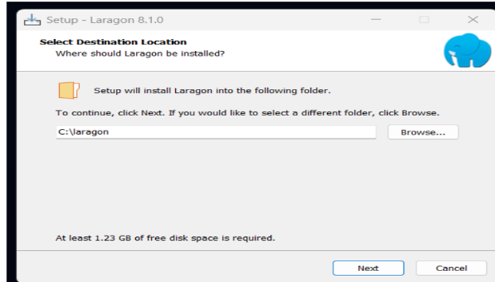

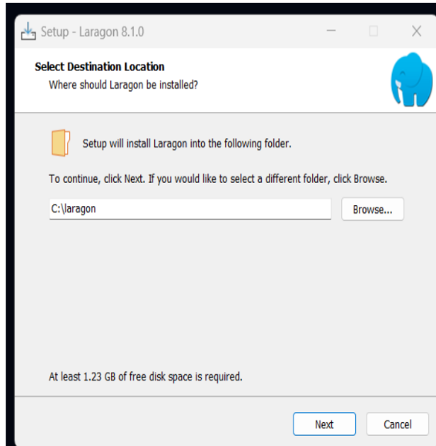

Fig 2: Apache and MySQL Running
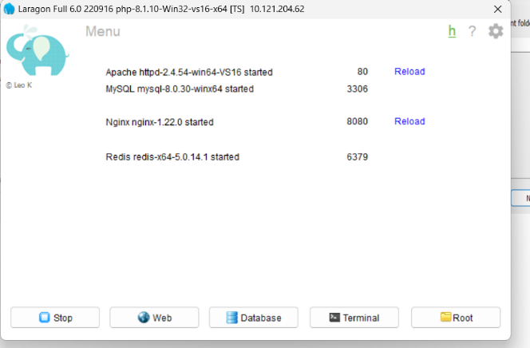

Fig 3 Local host test page
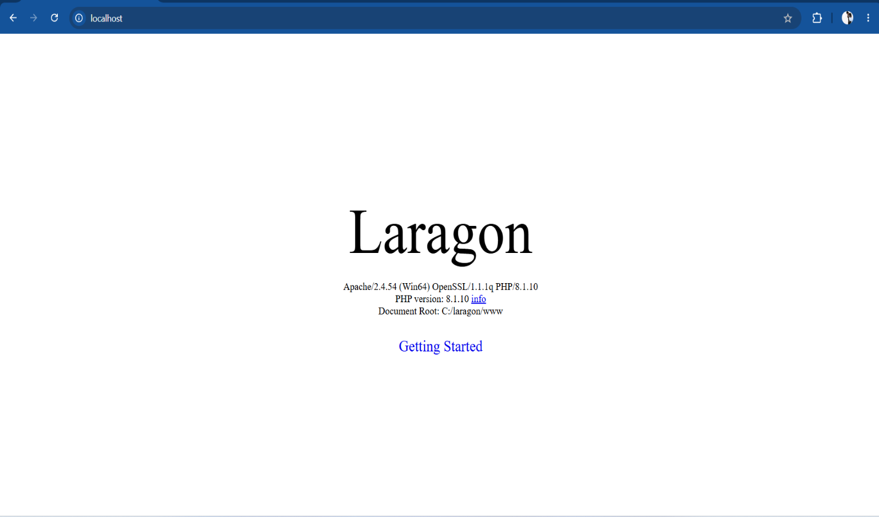

Reflection
During this week, I installed and configured the development environment required for FarmConnect Kenya. Laragon was used to host the application locally while MySQL was used for database management. I successfully tested PHP execution and database connectivity. This stage established the foundation necessary for implementing the system modules.

Week 2. Wireframes and GUI design
User Interface Planning and System Design
Evidence

Figure 2.0 system/ architectural design
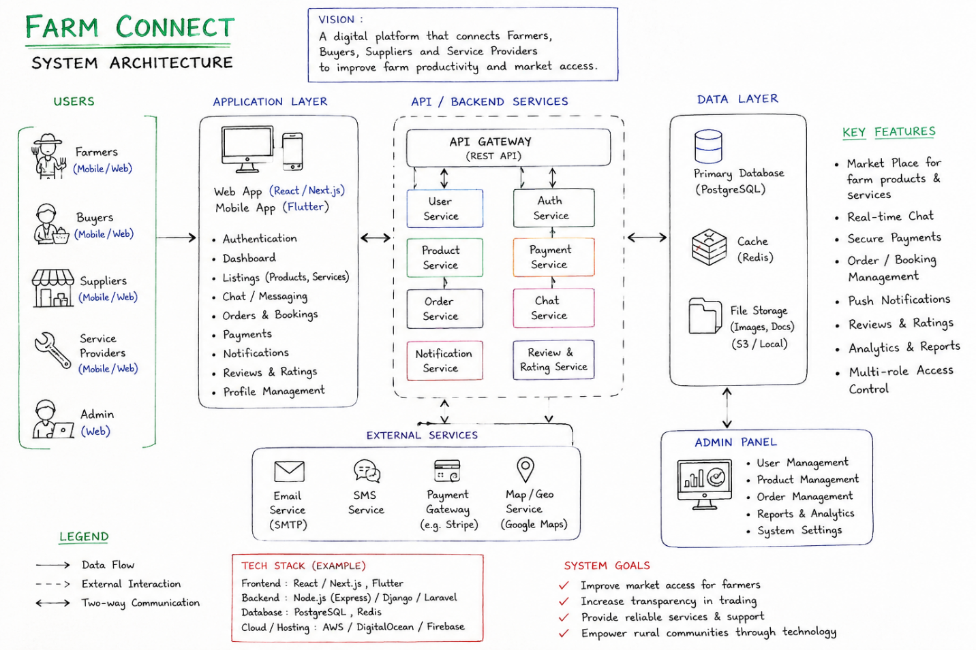

Fig 2.1 Designed homepage

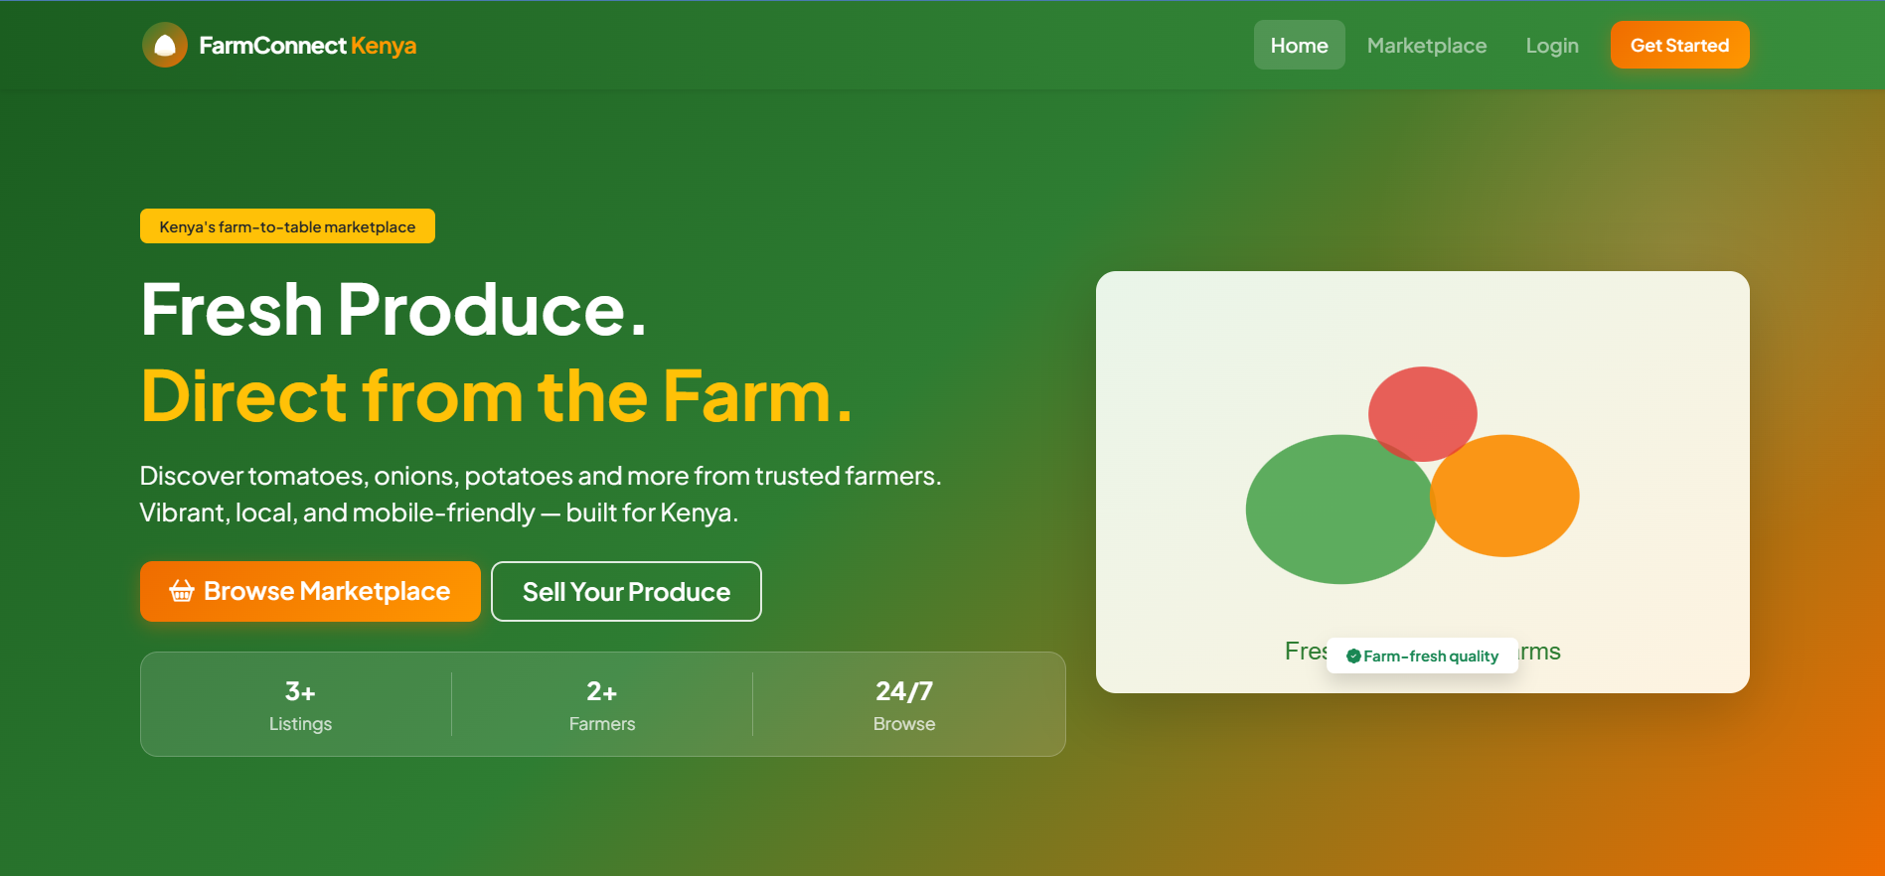

Fig 2.2 Designed login page
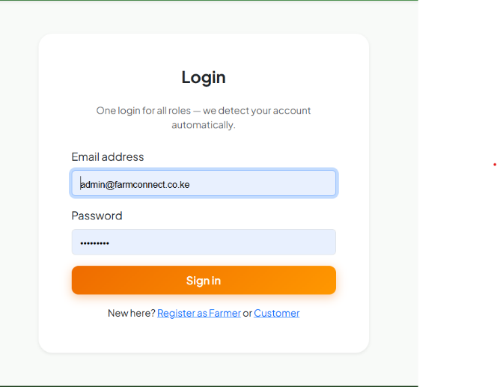
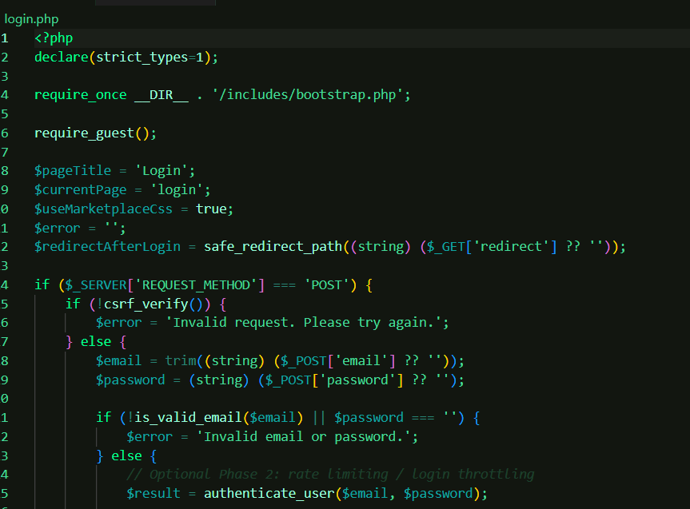

Fig.2.3 Designed registration page

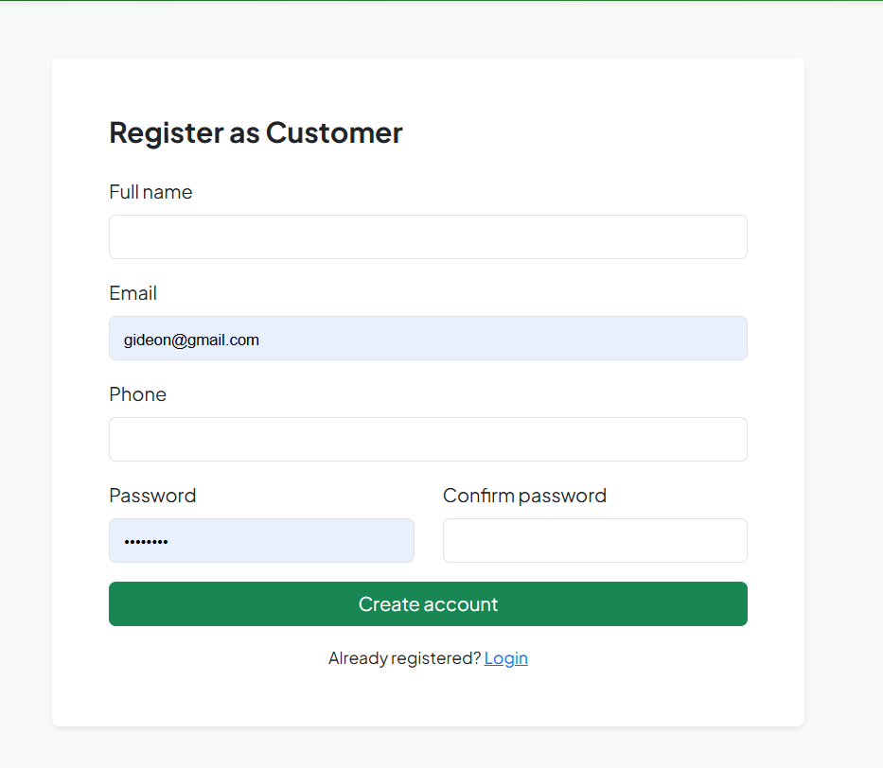
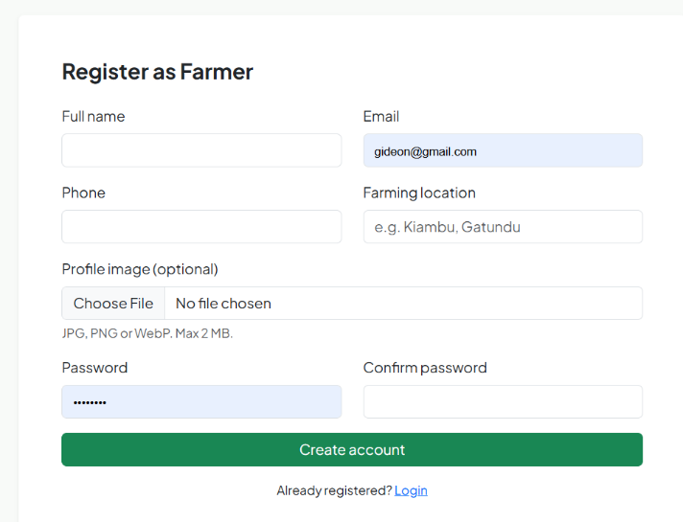

Fig 2.4 farmer dashboard
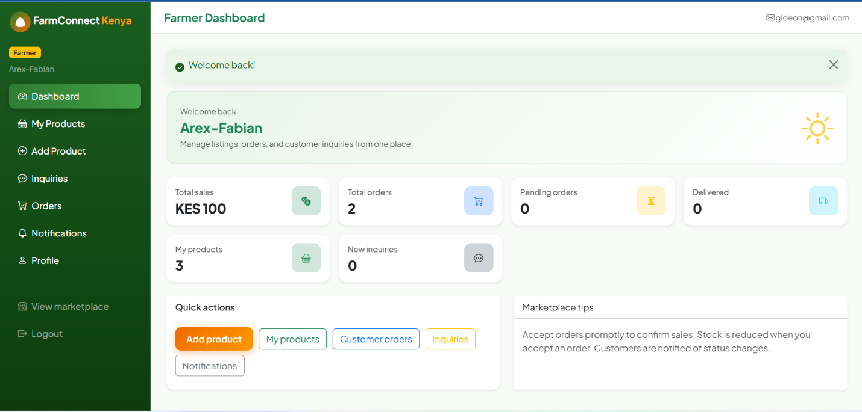

Fig2.5 Planned customer dashboard
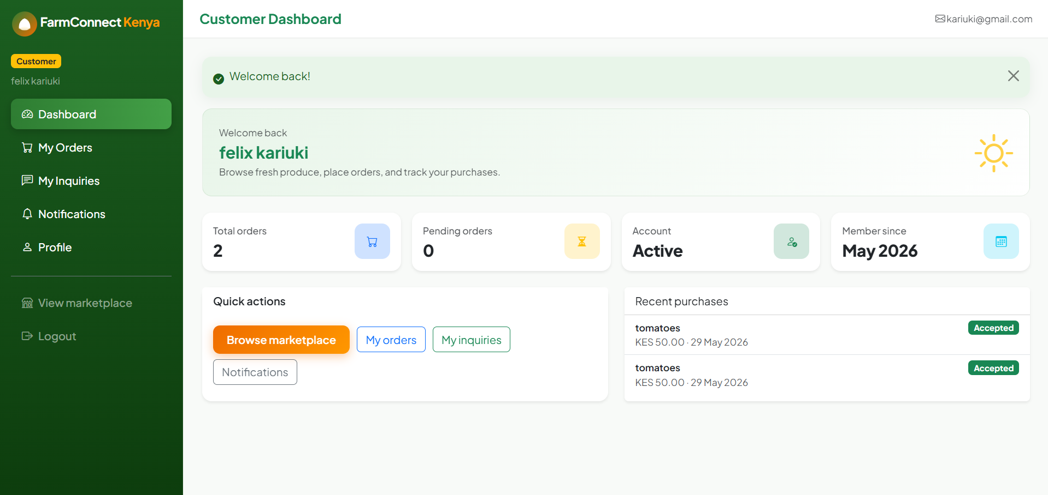

Fig 2.6 admin dashboard
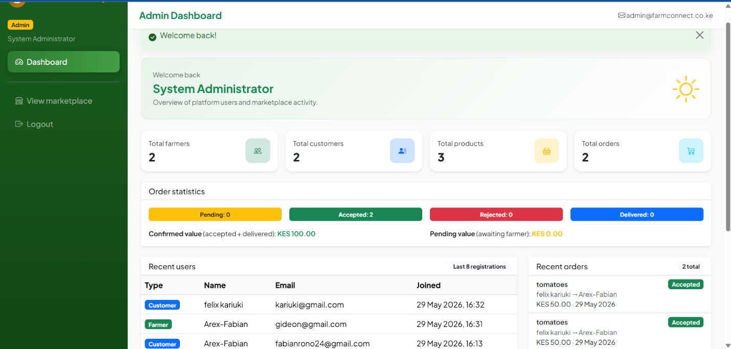

Fig 2.7 Navigation structure
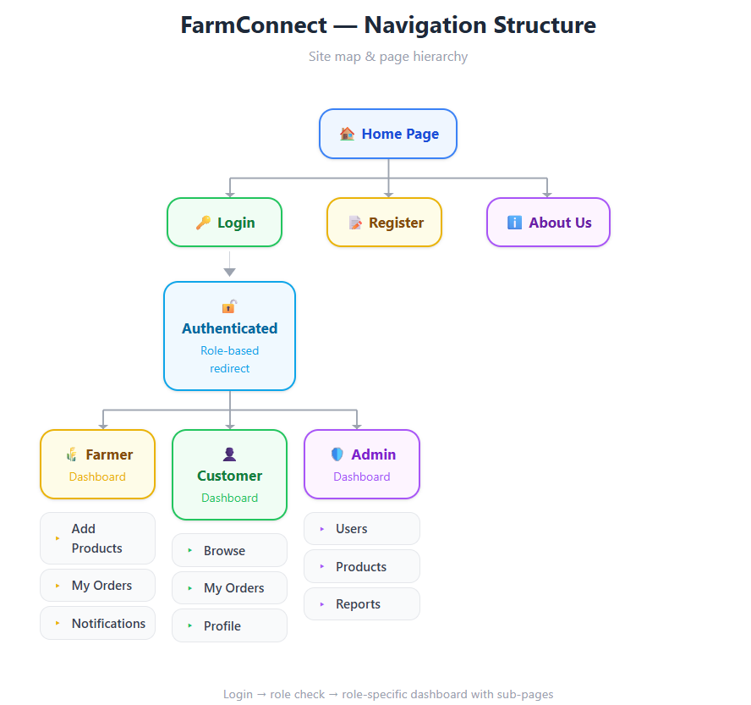

FIG 5. GUI Prototype in Figma

Fig 5.1 System architecture
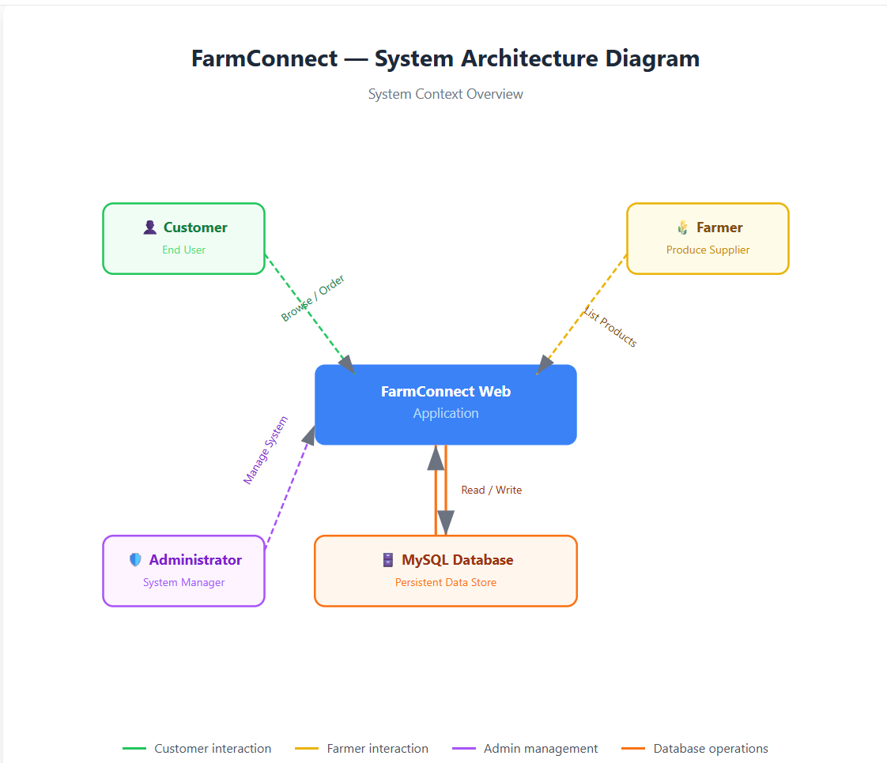

Fig 5.2 System workflow
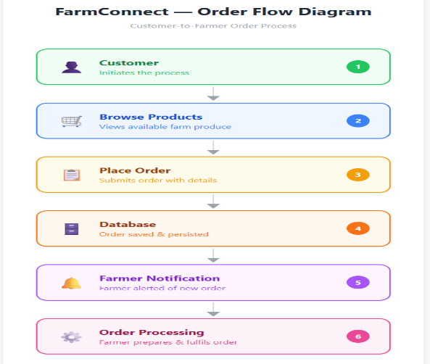

Reflection
The user interface was designed to provide a simple and intuitive experience for farmers, customers, and administrators. The navigation structure was planned carefully to ensure users could access important features with minimal effort. Dashboard layouts were designed to support future system expansion while maintaining usability.

Week 3.Frontend Interaction and Backend Foundations
System Development and Backend Integration

Evidence

Fig 1: Registration Form Validation

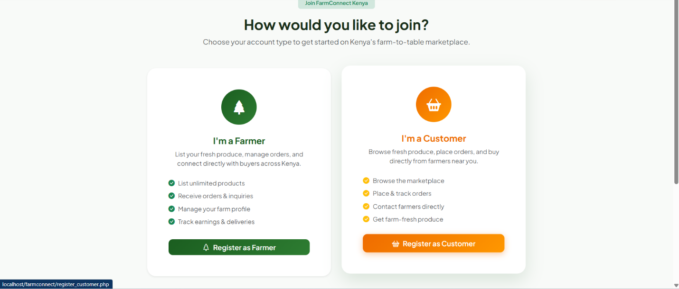

Figure 1.3 customer registration redirect

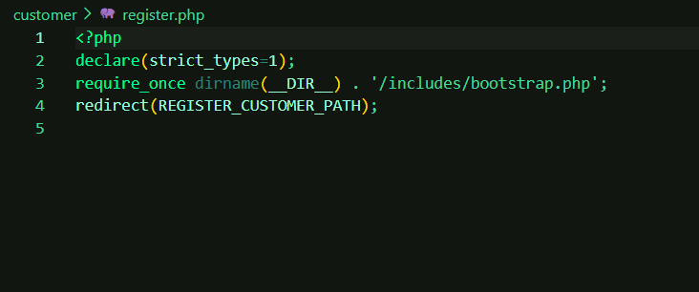

Figure 1.2 registration code

Fig 2: Login Authentication System
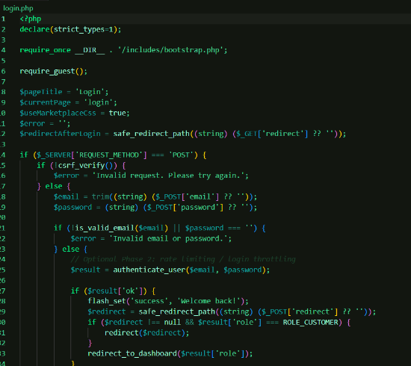

figure 2.1 login authentication code
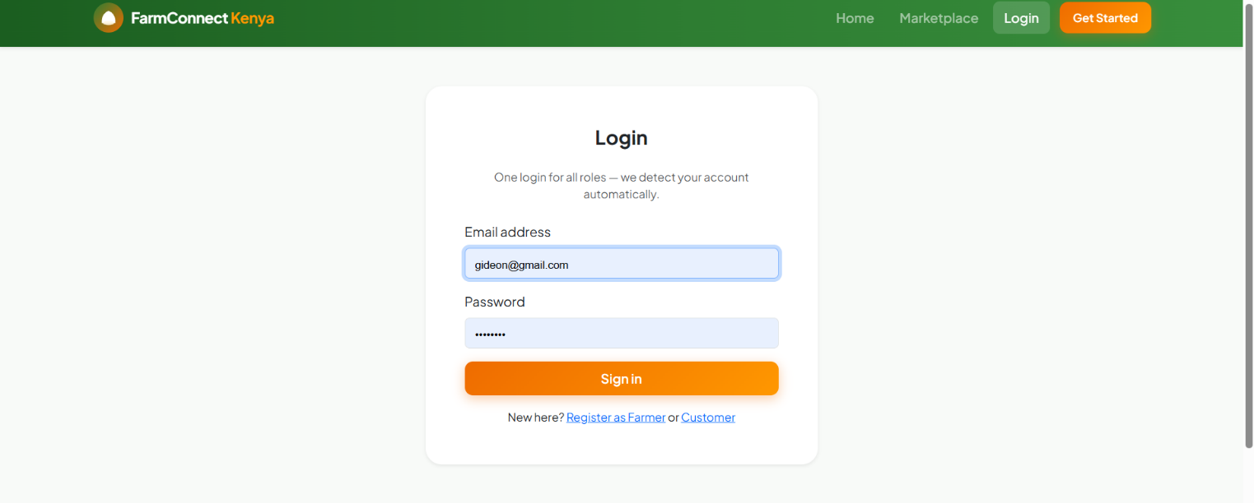
Fig 2.2 Login page

Fig 3: Farmer Product Management Module
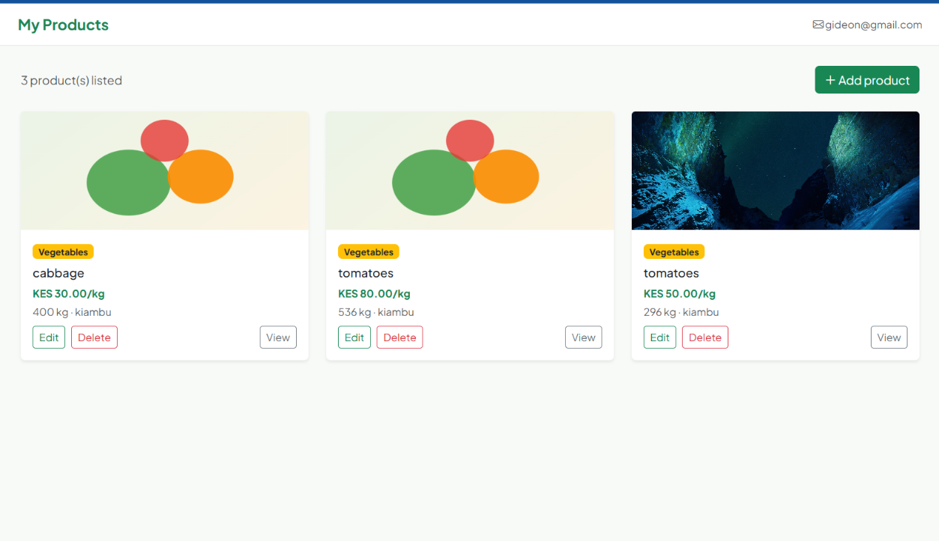
figure 3.1 farmer product manager

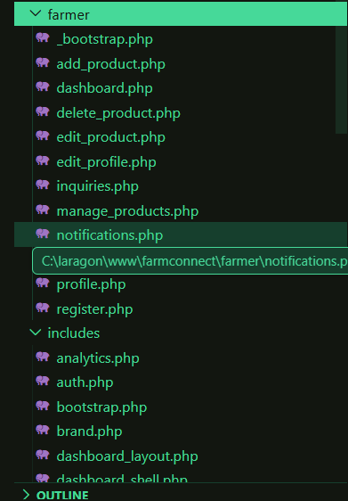

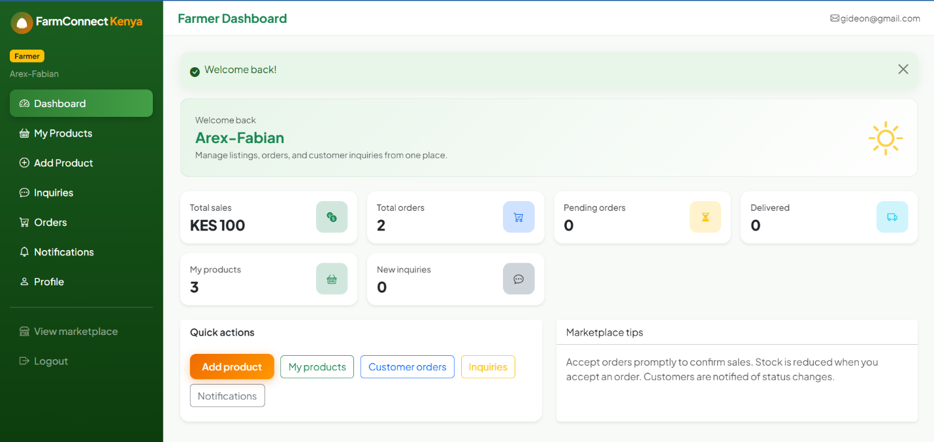

fig.3. 2 farmer controls and dashboard

Fig 4: Customer Marketplace Module
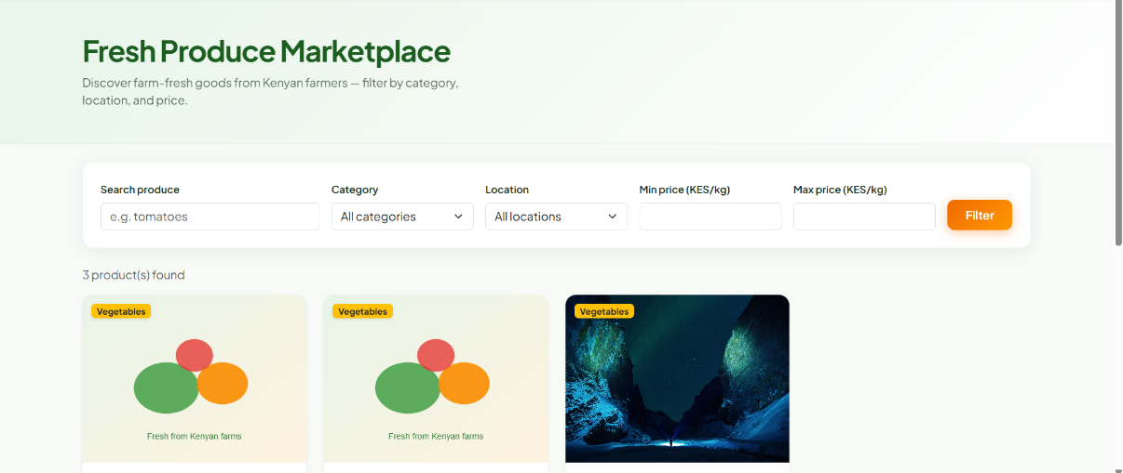

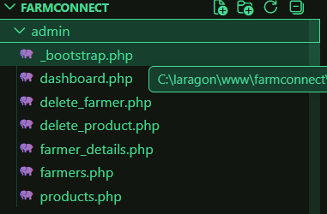
Figure 5.1 . admin dashboard code

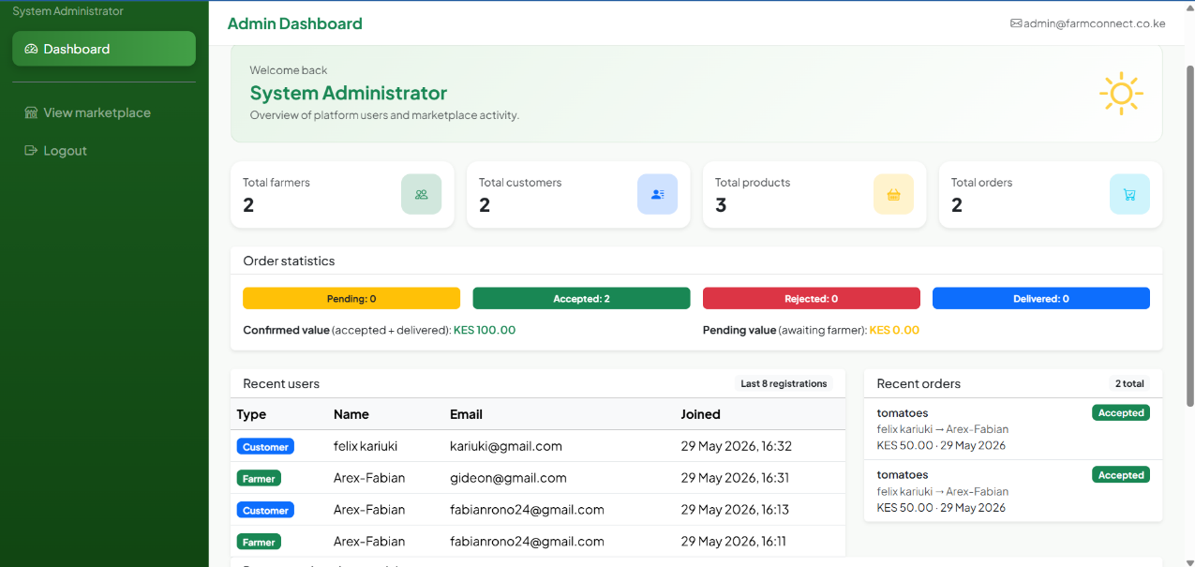
Fig 5.2 admin dashboard view

Reflection
During this phase, frontend and backend components were integrated using PHP and MySQL. Authentication functionality was implemented using sessions, while database operations supported product management and order processing. Testing was conducted to identify and fix issues related to navigation, database queries, and user authentication. The completed system successfully supports farmers, customers, and administrators through dedicated modules.

Week 4.Farmer Module development
Farmer Dashboard and Product Management System

Fig 4.1: Farmer Registration Module
The farmer registration module allows new farmers to create accounts and access the FarmConnect platform. User information is validated before being stored in the database.


Fig 4.2: Farmer Dashboard Interface
The farmer dashboard provides an overview of products, orders, inquiries, and notifications. It serves as the central control panel for farmers.
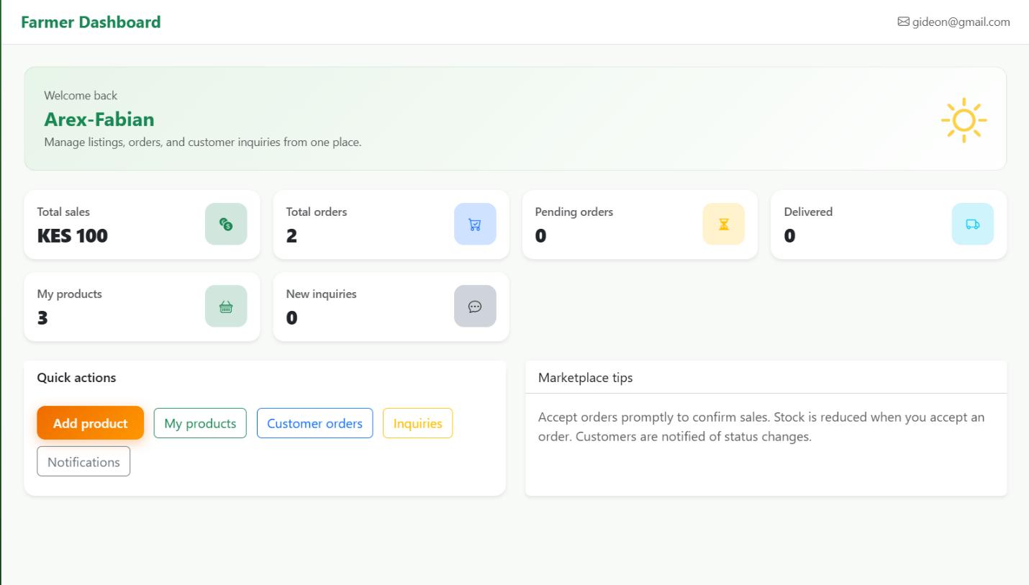

Fig 4.3: Add Product Form
This module enables farmers to add agricultural products by entering details such as product name, category, price, quantity, and image.
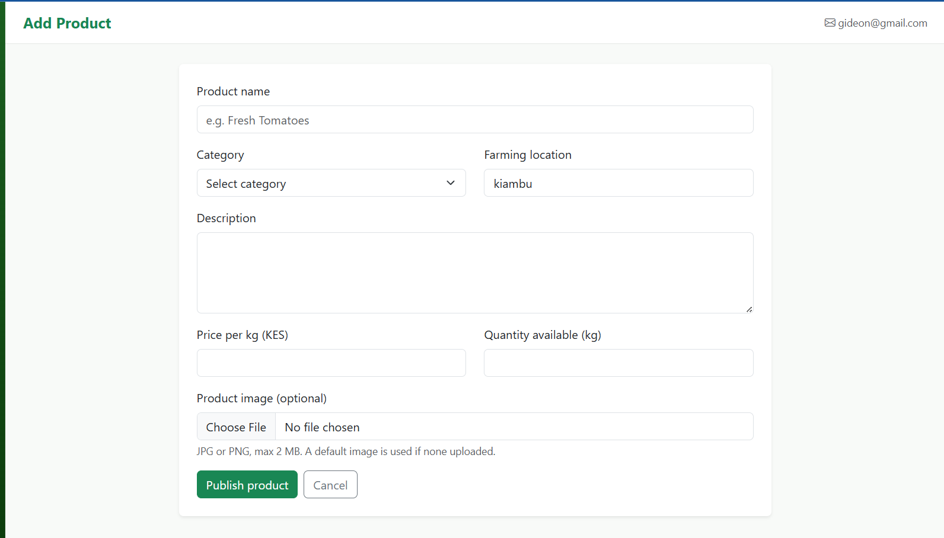

Fig 4.4: Product Management Interface
The product management page displays all products uploaded by a farmer and provides options for editing or deleting products.
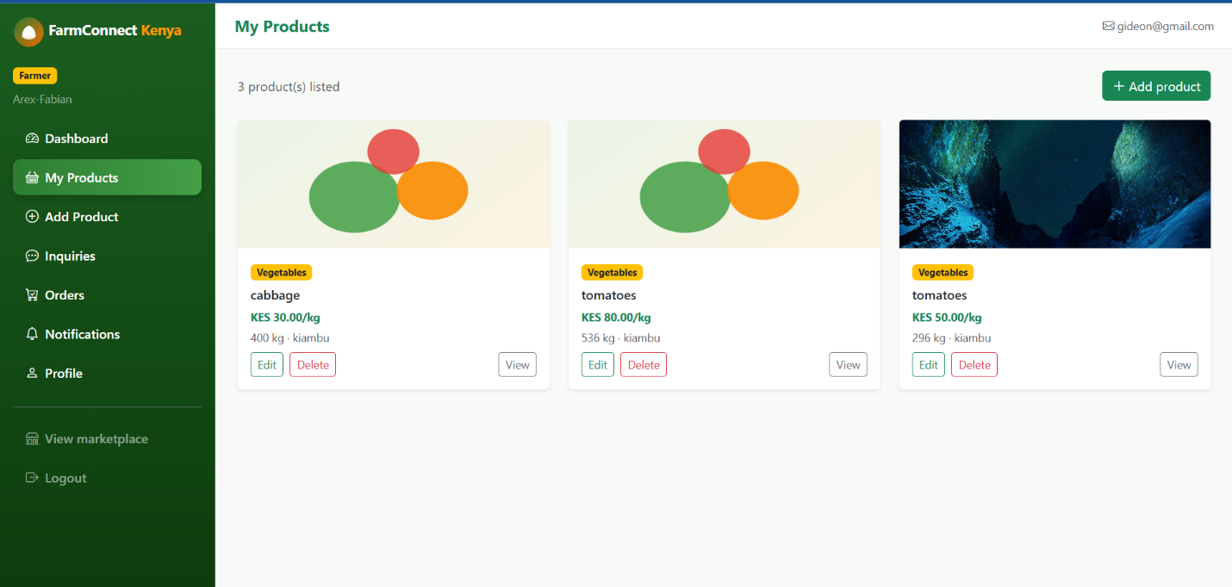

Fig 4.6: Farmer Orders Module
The orders module allows farmers to monitor customer orders and track transaction details.
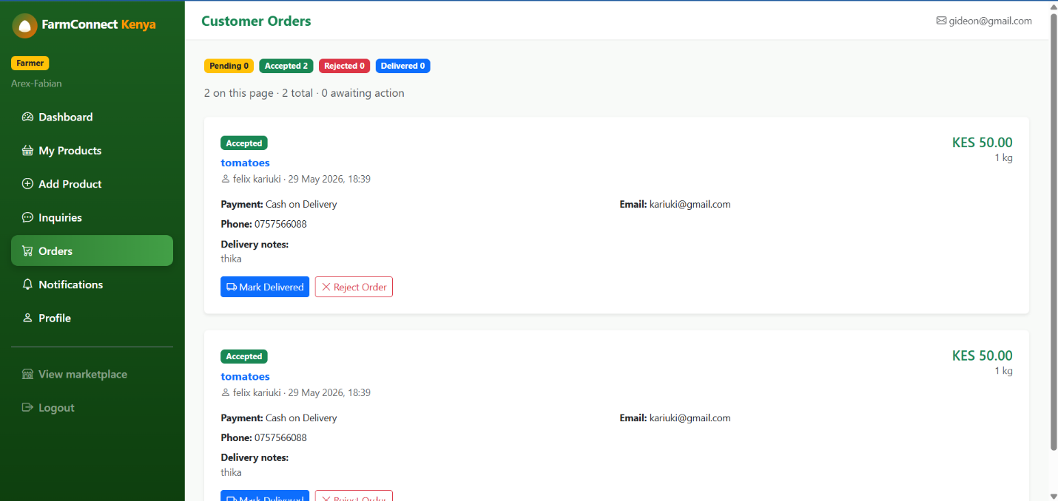

Fig 4.7: Customer Inquiries Module
farmers can view and respond to customer inquiries regarding products and services.
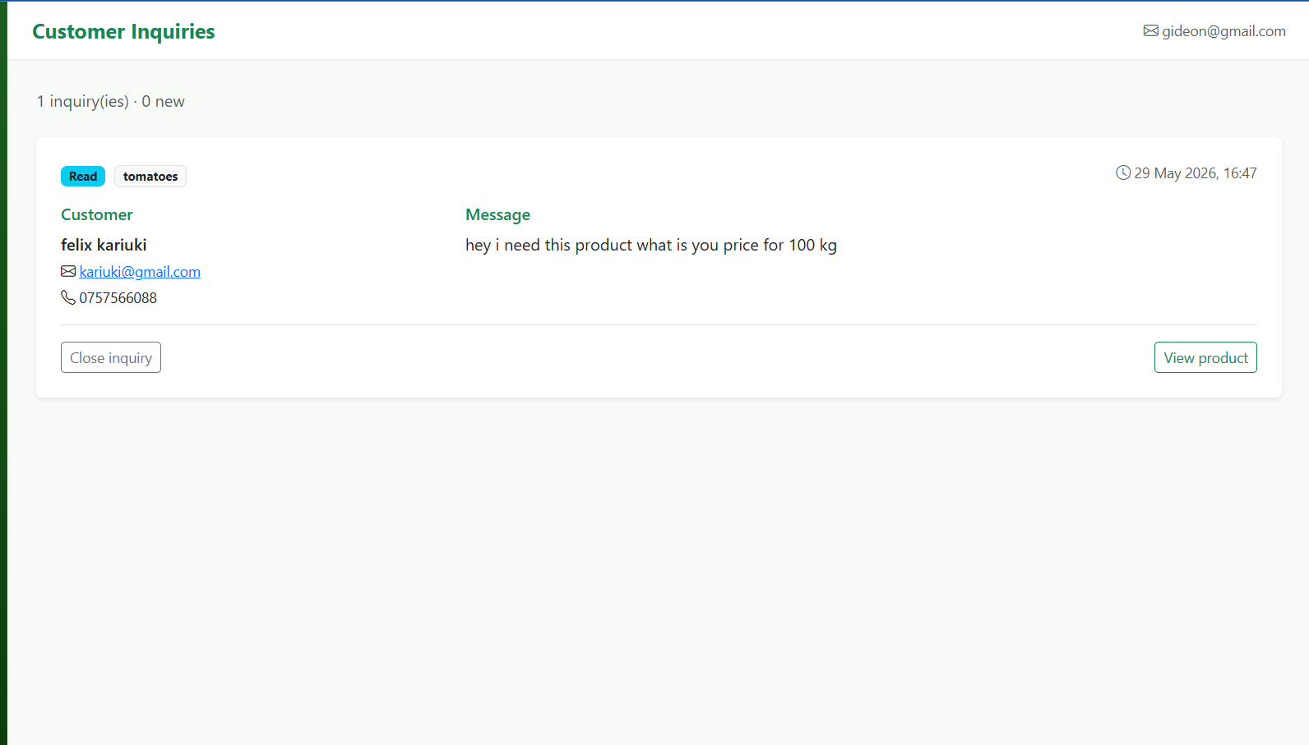

Reflection (week 5)
During this week, the Farmer Module was developed and integrated into the FarmConnect Kenya system. Core functionalities including farmer registration, dashboard management, product creation, product editing, product deletion, order monitoring, customer inquiries, notifications, and profile management were implemented using PHP and MySQL. Testing was conducted to verify database interactions, user authentication, and CRUD operations. The completed farmer module provides farmers with a centralized platform for managing agricultural products and interacting with customers efficiently.

Week 5. Database components and crude operation

Customer module development
Customer Marketplace and Order Management System

Fig 5.1: Customer Registration Module
The customer registration module enables users to create accounts and gain access to the FarmConnect marketplace. User information is validated before registration is completed.
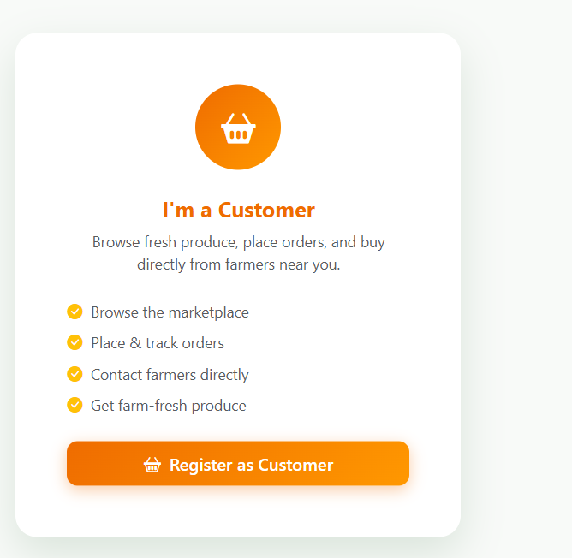

Fig 5.2: Customer Dashboard
The customer dashboard serves as the main interface where customers can access products, view orders, monitor notifications, and manage their profiles.
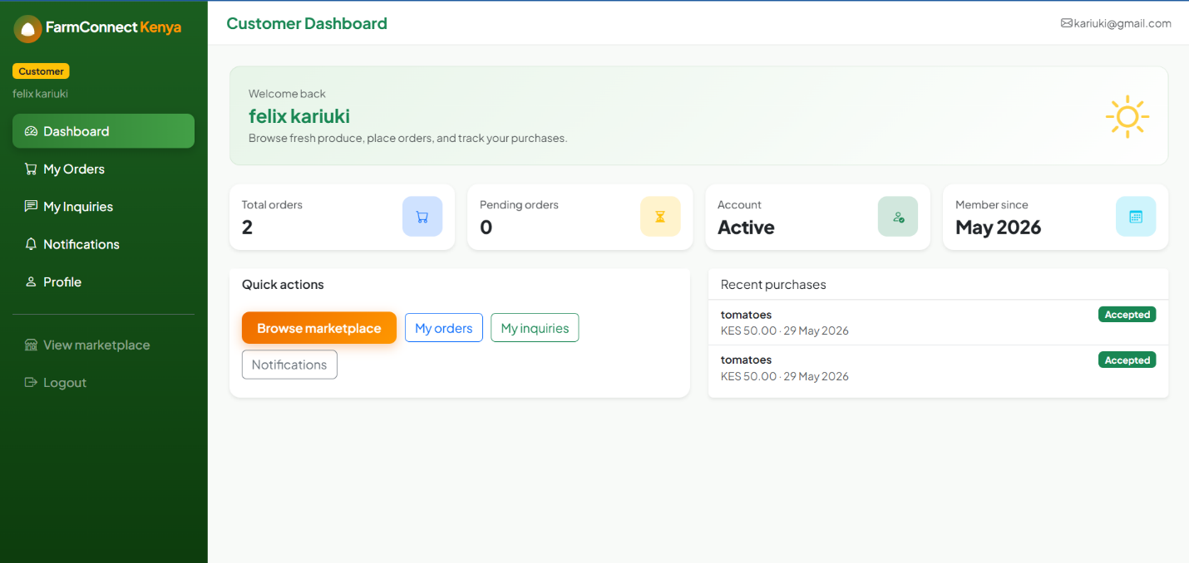

Fig 5.3: Product Marketplace
The marketplace displays products uploaded by farmers. Customers can browse available agricultural products and view essential information such as price, quantity, and category.

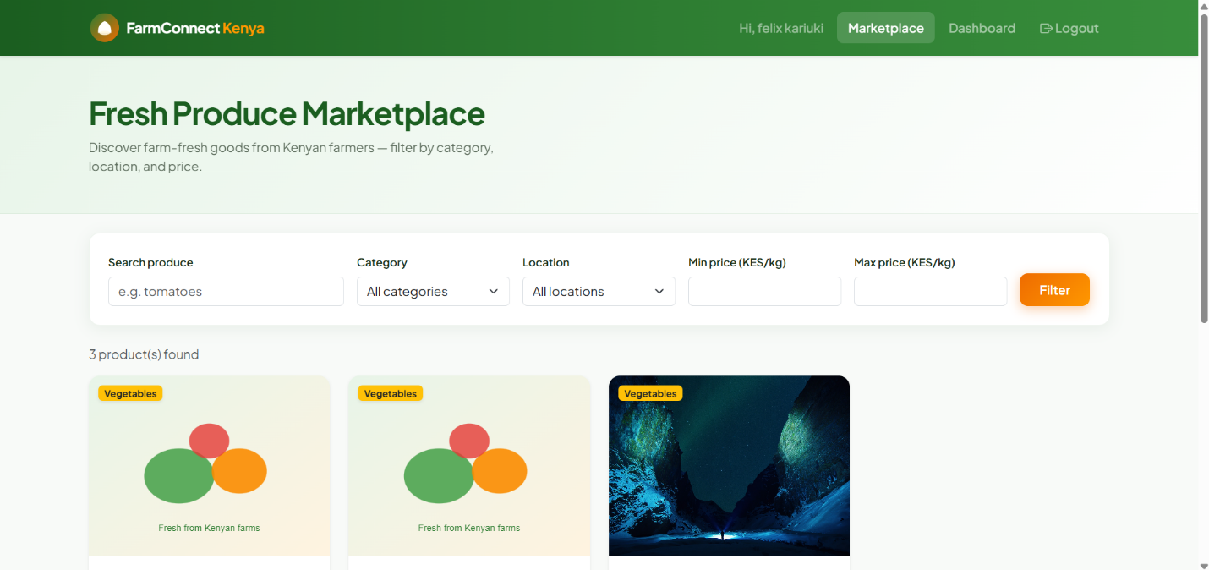

Fig 5.4: Product Details Page
The product details page provides comprehensive information about a selected product, including descriptions, pricing, and farmer details to assist customers in making purchasing decisions.
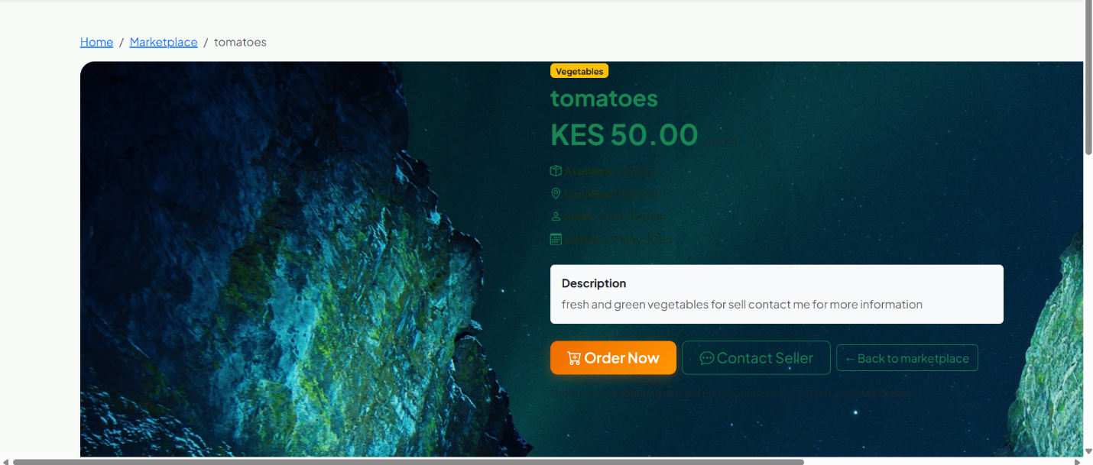

Fig 5.5: Customer Order Management
The order management module allows customers to view their orders, track purchases, and monitor transaction history.
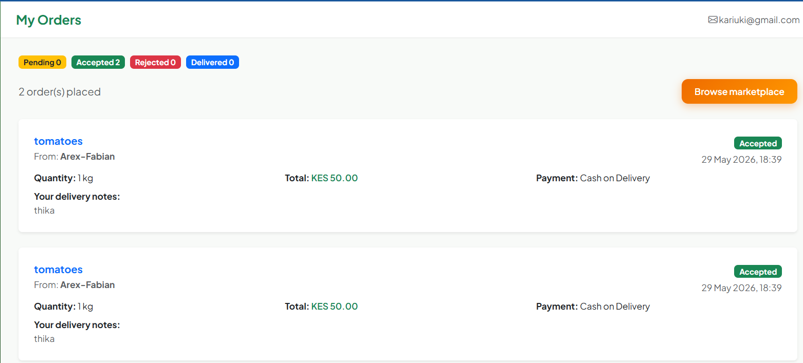

Reflection
During this week, the Customer Module was developed and integrated into the FarmConnect Kenya platform. Key features including customer registration, product browsing, product detail viewing, inquiry management, order tracking, notifications, and profile management were implemented using PHP and MySQL. Extensive testing was conducted to verify navigation, database connectivity, user authentication, and data retrieval processes. The completed customer module enables customers to interact effectively with farmers, browse agricultural products, and manage transactions through a user-friendly interface.

Week 6. Database components and crude operation

6.1 Customer Order Placement System

Fig 6.1: Product Selection for Ordering
Customers browse available agricultural products and select the desired item for purchase. Product information such as price, quantity, and seller details are displayed before order submission.

Fig 6.2: Order Placement Module
The order placement module captures customer purchase requests and validates product availability before processing the transaction.

Fig 6.3: Order Processing Logic
The backend logic receives customer order information, stores transaction details in the database, and updates the relevant product records.

Fig 6.4: Successful Order Submission
Upon successful validation and database insertion, the system confirms the order and notifies the customer that the transaction has been recorded.

Fig 6.5: Order Record Verification
The newly created order is displayed in the order management section, allowing both customers and farmers to track transaction progress.

Reflection
During this week, the order placement functionality was implemented and integrated into the FarmConnect Kenya system. The module enables customers to submit purchase requests directly from the marketplace while ensuring product information is validated before processing. PHP and MySQL were used to manage transaction records and maintain data consistency across the system. Testing focused on order creation, database updates, validation checks, and transaction visibility within customer and farmer dashboards. The completed module provides a reliable mechanism for connecting customers with farmers and facilitating agricultural product transactions.

